**Data Analysing and Visualising in Excel.**

**Objectives:**

In this project, we will learn the basics of creating a pivot table in Microsoft Excel. Pivot tables provide a way to automatically summarise, analyse, explore, and present data. Charts add visualisations to the data in the pivot table that analyses trends and comparisons.

**Please download the dataset ‘Bike_Sales_Pivot_Lab.xlsx’ from** [**here**](https://justit831-my.sharepoint.com/:x:/g/personal/danpe_justit_co_uk/Eb73L6LixCJHtafDJ4AOh-ABR9CVF0n9sdEgB4foSh261g?e=jh493A)**.**

**The lab instructions can be found** [**here**](https://justit831-my.sharepoint.com/:b:/g/personal/danpe_justit_co_uk/EVySAtWQiEVDmrtCufrqTgwBuLVxX6mEKYqEAe0Mgl6b9Q?e=i05yOa)**.**

**Background / Scenario**

The bicycle sales company wants to determine the purchasing patterns of different demographic groups to identify areas where it needs to concentrate its marketing efforts. The company also wants to see if there are purchasing differences between the countries where it operates.

Pivot tables can reveal useful information in records or data that is not obvious at first sight by summarising and re-presenting the data so trends can be explored and reported. Pivot tables extract meaning from the data by grouping it in different ways,

enabling useful conclusions to be made.

The "pivot" part of a pivot table stems from the fact that that the data can be rotated

(pivoted) to view it from a different perspective. It is important to note that pivot tables do not add to, subtract from, or otherwise change, the data; the pivot table just reorganises the data to reveal useful information.

**Part 1: Creating an Excel Pivot Table**

To facilitate readability of the data, resize the column widths and centre the data in the

numeric columns. This exercise will focus on Year, Age Group, Customer Gender, Country, and Order Quantity data. Accordingly, it may also be useful to hide the Customer Age, State, Product Category, Sub-Category, Product columns.

**Step 1: Create the pivot table.**

a. Download the Bike_Sales_Pivot_Lab.xlsx and open the file in MS 365 Excel online. Click the Insert menu tab and select Pivot Table. In the Create Pivot Table dialog box, make sure New Worksheet is selected and click OK.

b. In the PivotTable Fields dialog box, select the following fields: Year, Age Group, Country, and Order Quality.

The pivot table created displays each country grouped under each age group, with the

sum of the order quantity for each age group in total, and the total for each country under that age group.

**Step 2: Review the pivot table.**

Note that pivot tables will automatically sum numeric data under each heading. However, in this case, this produces the meaningless sum of all the year values. So, year values are not useful to include at this stage.

a. Uncheck Year in the PivotTable Fields dialog and update the pivot table. (Selecting any cell in the pivot table will bring the PivotTables Fields dialog box back up if it is no longer visible.) The information now makes more sense with the total of orders for each age group shown, with the country breakdown for that country.

b. In the pivot table, click the - (minus) beside each age group label to collapse (hide) the countries listed under that age group. To display the countries again, click the now displayed + (plus) displays the country sales numbers.

**Step 3: Rearrange the pivot table.**

To create a different view of the data, drag Country in the PivotTable Fields dialog box to the Columns pane. The updated pivot table now displays the countries as columns with sales totals for each age group and each country:

**Step 4: Refine the pivot table.**

The pivot table now contains blank cells, which detract from the readability of the table.

Excel can be instructed to fill each blank cell with zero.

a. Click the Pivot Table tab on the menu bar. Under Pivot Table, click Settings. In the field for empty cells show, select the checkbox and enter 0 (zero). Press Enter to update the table.

b. The column values can be centred for better readability. Centre all the columns with numbers.

c. The first column can be filtered to re-order the age groups from youngest to oldest. Click the Filter and Sort down arrow next to the Age_Group column heading. Click Sort Descending to sort age groups from Youth to Adults.

**Step 5: Revise the pivot table.**

To enhance the data analysis, select Customer_Gender to add the field into the pivot table. Note that any blank cells are automatically filled with zero as set from a previous step. Clicking the – next to each age group will hide the gender for that age group and + will expand that data category.

The Pivot table shown below:

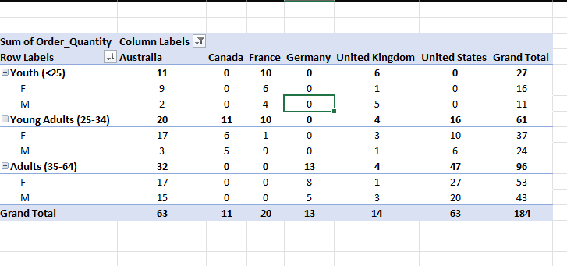

**Part 2: Visualising Pivot Table Data**

Presenting the pivot table as a graphical chart will highlight features of the data and assist in analysis and decision making.

**Step 1: Create a pivot table chart.**

a. Select all the cells in the pivot table. Click Insert from the menu bar. The chart icon group appears on the ribbon.

b. Find and select the stacked column icon in the drop down.

c. Re-size and move the chart for optimum clarity.

d. Right click the chart to bring up a pop-up menu and select Format from the menu list. This will bring up the Chart Format dialog. Click Chart Title. Change the Chart Title to “Sales Summary.” The resulting chart should look similar to the example below, but colours may vary.

**Step 2: Analyse the chart data.**

Remember the original aim was to determine where marketing effort needs to be applied in specific markets to reach under-represented demographic groups and to see if there are differences between the countries where it operates. The chart graphically shows that the youth age group is globally the poorest area of sales. Female adults are buying the most product. Questions that the company can pose, and then develop business decisions in relation to, may include:

• Why does the youth age group have the lowest sales globally?

• Why are there sales in Australia in all categories except male youth?

• Why are there no sales to adult males in France?

• Why is there only one successful market category in the United Kingdom?

**Step 3: Revise the chart format.**

You can revise the chart, so it only shows the values for each age group.

Click the – next to each age group in the pivot table to hide the gender information. This chart now shows the aggregated sales data across each age group for each country.

The finished chart shown below:

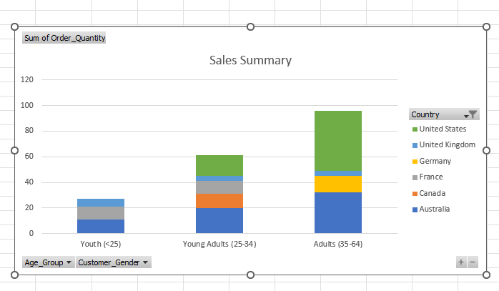

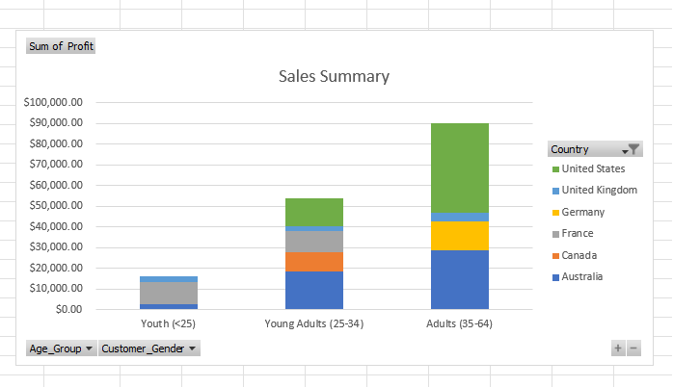

**Key Findings:**

Australia & United Kingdom has sales in all markets

Germany has bike sales only on Adult group.

Canada, Germany and United States there was no bike sales on Youth group.

Canada and France there was no bike sales on adult female group.

Most Profitable market by country- United States

Most Profitable market by age group – Adults (35-64)

Most Profitable market by gender - Female

**Part 3: Create different charts to visualise data in Microsoft Excel.**

**A) Creating a Line Chart**

**Step 1: Insert the line chart.**

a. Select the Revenue and Profit by Year worksheet. The worksheet contains the profit and the revenue totals for each of the years 2017, 2018, 2019, 2020, and 2021.

b. Select the data in the cells A3 through to C8.

c. From the Insert menu, expand the ribbon using the down arrow on the right side of the ribbon, click the Line chart tool, then select Line with Markers (bottom left option)

This creates a line chart with an x-axis showing the years, and a y-axis dollar amounts.

**Step 2: Format the chart.**

a. To improve the clarity of the chart, change the vertical axis to display USD currency.

1. Right click on the chart and select Format. The Chart Format window pane opens on the right of the worksheet.

2. Expand the options for the Vertical Axis.

3. In the Number Format section change Category to Currency and change Decimal places to 0.

b. Add a chart title

1. In the Chart Format window pane, change the Chart Title option switch to the on position if it is not already and expand the Chart Title options.

2. Change the Chart Title to “Revenue vs. Profits”.

3. Keep the Title Position at the default which is Above.

c. Change the Legend names to “Annual Profit” and “Annual Revenue”.

1. Select cell B3 and change the column name to Annual Profit.

2. Select cell C3 and change the column name to Annual Revenue.

The legend names at the bottom of the chart should change to match the column names.

d. Reposition the Legend to the right of the chart.

1. Right click on the chart to bring up the Chart Format window pane.

2. Expand the options for Legend.

3. Change the Position option to Right.

e. Add axis titles for both the vertical and horizontal axis.

1. If necessary, right click on the chart to bring up the Chart Format window pane.

2. Expand the Horizontal Axis options.

3. Scroll down to the Axis Title and move the switch to the on position.

4. Add an axis title of “Year”.

5. Expand the options for the Vertical Axis.

6. Scroll down to the Axis Title and move the switch to the on position.

7. Add an axis title of “US Dollars”.

The Line chart shown below:

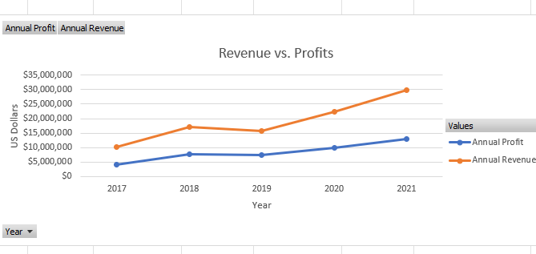

**B) Creating a Column Chart**

**Step 1: Insert the Column Chart**

a. Select the Product Revenue by Country worksheet. The worksheet contains the revenue totals for each product category by country.

b. Select the data in the cells A3 through to E10.

c. From the Insert menu, click the Column chart tool, then select the Stacked Column. This creates a column chart with an x-axis showing the country, and a y-axis showing dollar amounts.

**Step 2: Format the chart.**

a. Using the same methods used for the line chart perform the following formatting changes to the chart.

1. Give the chart a title of “Product Revenue by Country”.

2. Change the vertical axis Number Format to Currency and the Decimal Places to zero

3. Change the Position of the Legend to the Right.

4. Add a horizontal Axis Title of “Country”.

5. Add a vertical Axis Title of “US dollars”

The Column chart shown below:

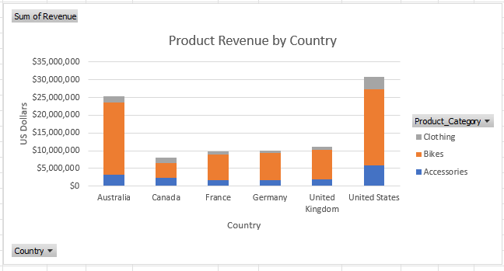

**C) Creating a Pie Chart**

**Step 1: Insert the Pie Chart**

a. Select the Revenue by Age Group worksheet. The worksheet contains the revenue totals for each product category.

b. Select the data in the cells A3 through to B7.

c. From the Insert menu, click the Pie chart tool, then select the 2D- Pie

This creates a pie chart with each age group represented by an area on the cart representative of the revenue for that group.

**Step 2: Format the chart.**

a. Using the same methods used previously for the line and column carts make the following format changes:

1. Give the chart a title of “Revenue Comparison by Age Group”.

2. Change the Position of the Legend to the Right.

b. Add data labels to the chart area.

1. In the Chart Format window expand the options for Series “Total:

2. Expand the options for Data Labels.

3. Check the boxes for Category Name and Percentage.

The Pie Chart shown below:

